*IgemRNA* is a library with a graphical user interface written for the MATLAB environment and facilitates some of the Cobra Toolbox 3.0 functionality. *IgemRNA* performs not only Gene sets enrichment analysis-based functions, but also allows integrate transcriptomics data in metabolic models. Also, *IgemRNA* allows validate transcriptomics data facilitating interconnectivity of biochemical networks, steady state assumptions, Gene - Protein - Reaction relationship and can use optional medium composition data to create context-specific models.

1. Folder structure description

Files are extracted from the archive (https://github.com/BigDataInSilicoBiologyGroup/IgemRNA). The *IgemRNA* tool consists of four root folders (*Data, Scripts and Results non-optimization, Results post-optimization*) and an *IgemRNA.m* file which calls the user graphical interface form. Data folder is where the input data files are stored, initially this folder contains the data files used for this demonstration:

* MediumData.xlsx (medium composition data);
* Yeast_8_4_0.xls (the yeast consensus genome-scale model)
* TranscriptomicsData.xlsx (RNA-req measurements) (available <https://www.ncbi.nlm.nih.gov/geo/query/acc.cgi?acc=GSE130549>)

Transcriptomics data and medium composition data can be provided as an .xls or an .xlsx file and must meet the following format (Figure 1) where shown columns are provided and named accordingly and sheet names correspond to a phenotype name see 3.2 *IgemRNA* demonstration.

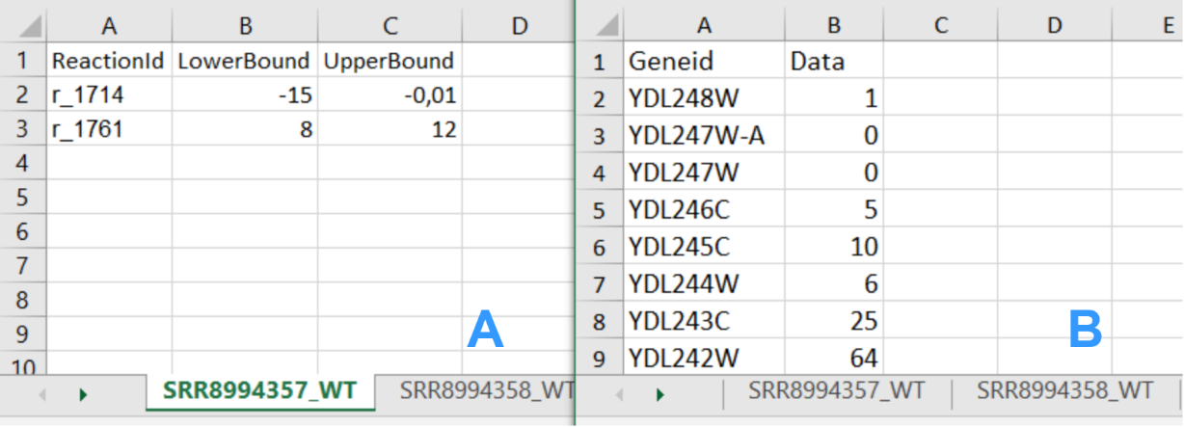

**Figure 1.** Input data file structure; (A) Medium data file structure;

(B) Transcriptomics data file structure.

The model can be provided in xls, sbml or other formats supported by Cobra Toolbox 3.0.

Scripts folder consists of all the script files that are being executed by the *IgemRNA* tool according to user's selections in the *IgemRNA* form as well as the test cases provided in this demonstration.  
The Results non-optimization and Results post-optimization folders are where all the result files are being saved. These folders are initially empty (for more details see section in main publication Materials and Methods 2.2 Tools functionality description).

1. Starting *IgemRNA* tool

In order to start the *IgemRNA* tool a user must start the MATLAB environment and run the *IgemRNA.m* script located in the root folder. This script opens the graphical user interface of *IgemRNA* (Figure 2).

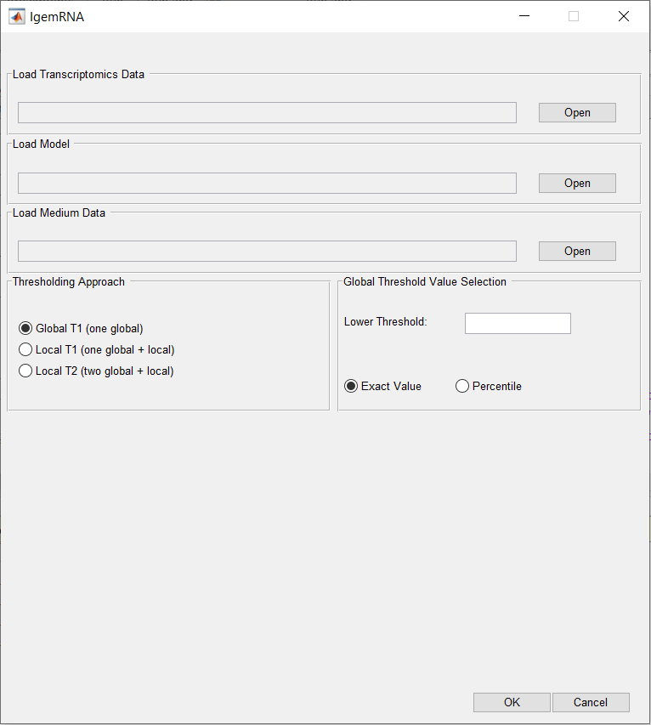

**Figure 2.** IgemRNA start window.

1. File upload

To access all options in the *IgemRNA* form, the user must supply input data files Figure 3 A section. This can be done by pressing the ‘Open’ button in the corresponding file row and finding the necessary files via File Explorer. Transcriptomics data is required to run non-optimization tasks (Figure 3 F) but an additional model file is necessary to access the post-optimization tasks (Figure 3 G). Medium composition file is optional if such data is available, the selection of this data file does not extend the form, but specifies the given exchange reaction constraints (upper bounds and lower bounds) on the model for post-optimization tasks analysis. For an organized overview of the analysis and results it is recommended that the necessary data files are located in the Data folder of *IgenRNA* tool (for more details see main publication section Materials and Methods 2.2 Tools functionality description).

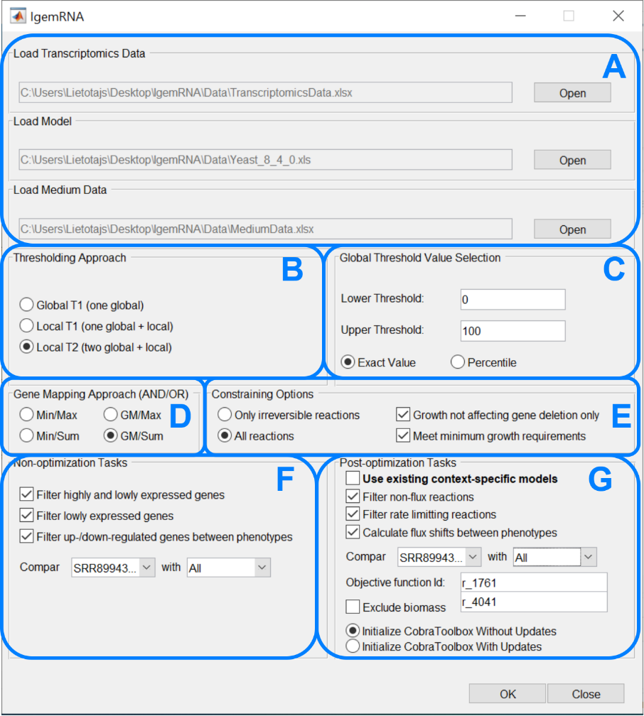

**Figure 3.** Full *IgemRNA* form

1. Running test cases

In order to perform test cases provided in this user manual, simply run the provided test case scripts via MATLAB environment having initialized CobraToolbox 3.0 beforehand. Test case script file names are given at the end of each test case section.

1. Non-optimization tasks

Non-optimization tasks include several transcriptomics data analysis tasks: filter highly and lowly expressed genes, filter lowly expressed genes, filter up/down regulated genes between different phenotypes or data sets. The results for each task are stored in a different folder within the *Results non-optimization* folder: *Gene expression level comparison, Highly-lowly expressed genes, Lowly expressed genes* (Figure 4).

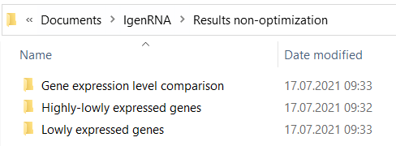

**Figure 4.** Non-optimization results folder

* 1. Filter highly and lowly expressed genes

Non-optimization task *Filter highly and lowly expressed genes* generates result excel files for each provided transcriptomics data set. File names are assigned based on the provided dataset and phenotype name (from transcriptomics data), the selected thresholding approach (GT1, LT1, LT2) and provided global thresholds values (Figure 5).

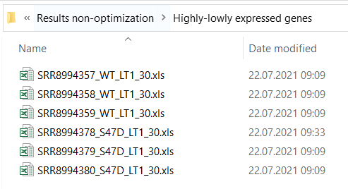

**Figure 5.** Highly-lowly expressed genes folder

Each excel file contains one sheet with the list of genes provided by transcriptomics data and 4 columns: *GeneId*, *Data* (the expression value), *ExpressionLevel* and *ThApplied*. The *ExpressionLevel* column contains the expression levels determined based on the chosen thresholding approach, provided global and for thresholding approaches (LT1 and LT2) calculated local thresholds. Column *ThApplied* displays whether a local or a global threshold for a specific gene was applied (Figure 6).

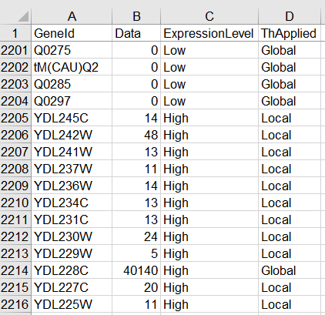

**Figure 6.** Filter highly and lowly expressed genes result file (thresholding approach LT1)

To perform this test case run files from the *Scripts* folder of *IgemRNA* tool:

*TestCase_findHighlyLowlyExpressedGenesGT1.m*

*TestCase_findHighlyLowlyExpressedGenesLT1.m*

*TestCase_findHighlyLowlyExpressedGenesLT2.m*

Or run full tests from the root folder of *IgemRNA*:

*ShortTest.m*

*LongTest.m*

* 1. Filter lowly expressed genes

Non-optimization task *Filter lowly expressed genes* generates separate excel result files for each dataset provided in transcriptomics data file. These result files contain filtered gene lists including genes that are below a given threshold based on the selected thresholding approach. File names include dataset and phenotype name (from transcriptomics data file), thresholding approach (GT1, LT1, LT2) name and provided global threshold values (Figure 7).

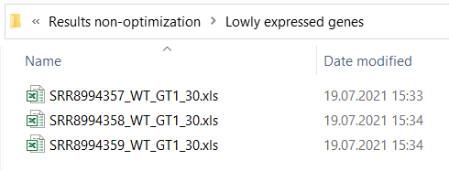

**Figure 7.** Non-optimization results folder

The result for lowly expressed genes coincides with the provided transcriptomics data format. Each file consists of 4 columns *GeneId*, *Data* (expression value from transcriptomics data), *ExpressionLevel* (Low) and *ThApplied* to show whether a global or local threshold was applied. Only those genes that are below a given threshold (depending on which thresholding approach is applied) are listed in the result files. The test case provided for this task shows genes with expression level below 30 using the Local T2 approach (Figure 8).

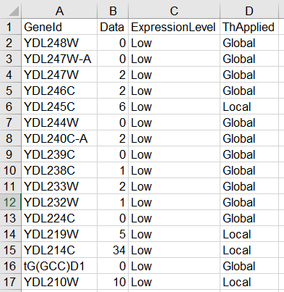

**Figure 8.** Lowly expressed genes result file

To perform this test case run files from the *Scripts* folder of *IgemRNA* tool:

*TestCase_findGenesBelowThresholdGT1.m*

*TestCase_findGenesBelowThresholdLocal1.m*

*TestCase_findGenesBelowThresholdLocal2.m*

Or run full tests from the root folder of *IgemRNA*:

*ShortTest.m*

*LongTest.m*

* 1. Filter up/down regulated genes between phenotypes

Non-optimization task *Filter up/down regulated genes between phenotypes* generates result excel files in the *Gene expression level comparison* folder. Result file names contain dataset and phenotype names for both transcriptomics datasets that have been compared (Figure 9).

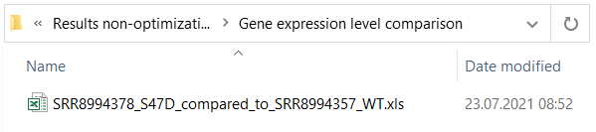

**Figure 9.** Up/Down regulated genes in comparison to another phenotype

These result excel data files contain a full gene list from the target dataset and the corresponding genes that are found in the source dataset (Figure 10. A column). Expression values for both target and source dataset are displayed (Figure 10. B, C columns) as well as the determined up/down regulation status (Figure 10. D column).

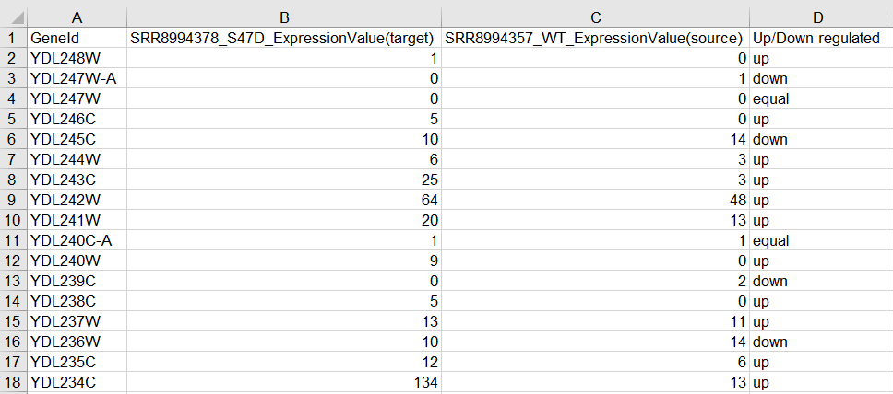

**Figure 10.** Up/Down regulated genes in comparison to another phenotype result file

To perform this test case run the file *TestCase_findUpDownRegulatedGenes.m* in the *Scripts* folder of *IgemRNA* tool or run full tests from the root folder of *IgemRNA*:

*ShortTest.m*

*LongTest.m*

1. Post-optimization tasks

Context-specific models generated by *IgemRNA* post-optimization tasks as well as the results of the analysis performed on these models are saved in the *Results post-optimization* folder of *IgemRNA* tool (Figure 11). The post-optimization tasks are saved in the folders with the corresponding name: Flux-shifts, Non-flux reactions and Rate limiting reactions (for more details see section Materials and Methods 2.2 Tools functionality description).

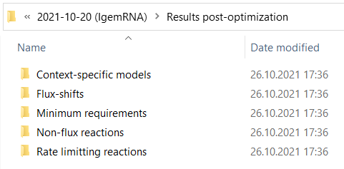

**Figure 11.** Results folder after post-optimization task execution

To generate context-specific models used for these test cases run the file *TestCase_createContextSpecificModel.m* in the *Scripts* folder of *IgemRNA* tool. Since this script takes a long time to execute, the context-specific model files used for this demonstration have already been provided in the ‘Results post-optimization/Context-specific models’ folder.

* 1. Filter non-flux reactions

Post-optimization task *filter non-flux reactions* performs an analysis on the created context-specific models of the same phenotype, the name of the phenotype is included in the result file name (Figure 12). This analysis filters those reactions that carry no flux.

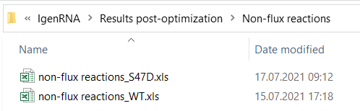

**Figure 12.** Non-flux reactions result folder

Each result excel file contains a list for each transcriptomics dataset of reactions that carry no flux in the result context-specific model created by integration of the supplied transcriptomics data into the provided model. An additional sheet for all the common non-flux reactions of the same phenotype is also provided in the sheet *Common (phenotype name)* (Figure 13).

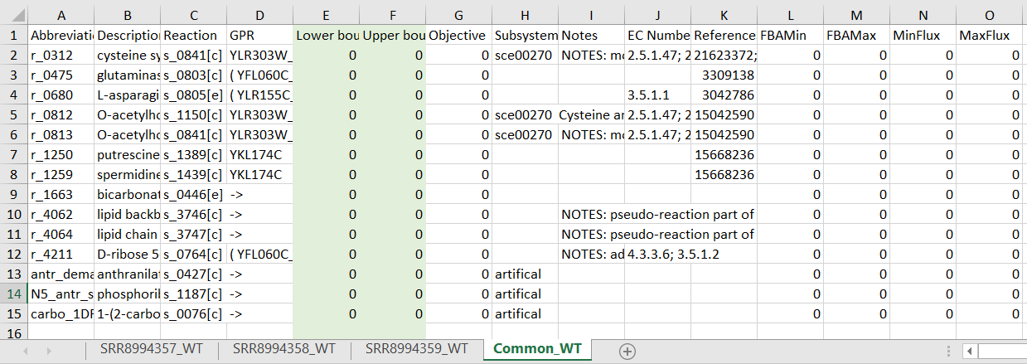

**Figure 13.** Wild type non-flux reaction task result

To perform this test case run the file *TestCase_filterNonFluxReactions.m* in the *Scripts* folder of *IgemRNA* tool or run full tests from the root folder of *IgemRNA*:

*ShortTest.m*

*LongTest.m*

* 1. Filter rate limiting reactions

Post-optimization task *filter rate limiting reactions* performs analysis on the generated context-specific models of the same phenotype, the phenotype name is included in the result files (Figure 14).

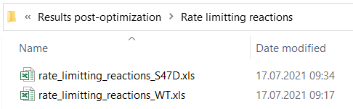

**Figure 14.** Rate limiting reactions result folder

Each result file contains sheets for each provided transcriptomics dataset of the same phenotype that has been integrated in the supplied model creating context-specific models. An analysis on these context-specific models have been performed in order to filter reactions that have reached the maximal flux (MaxFlux calculated by FVA) based on the upper bound set according to transcriptomics data and GPR associations. An additional sheet for common rate limiting reactions has also been added to the result file where rate limiting reactions that are present in all datasets are listed (Figure 15).

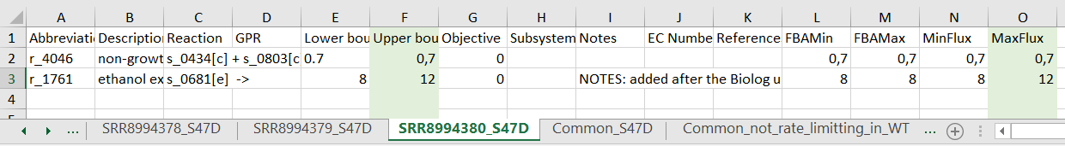

**Figure 15.** S47D phenotype rate limiting reaction task result

To perform this test case run the file *TestCase_filterRateLimittingReactions.m* in the *Scripts* folder of *IgemRNA* tool or run full tests from the root folder of *IgemRNA*:

*ShortTest.m*

*LongTest.m*

* 1. Flux shifts calculation between different phenotypes

Post-optimization task *calculate flux shifts between phenotypes* compares flux values (calculated by FVA on the context-specific models) between two different phenotypes. In this demonstration flux shifts analysis task was performed on the S47D phenotype datasets using Global T1 thresholding approach with the lower global threshold value of 0, phenotype SRR8994358_WT was compared to the wild type dataset SRR8994357_WT of the same thresholding approach and threshold values (Figure 16).

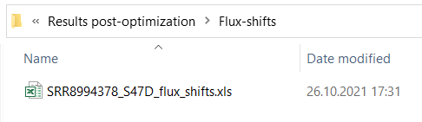

**Figure 16.** Flux-shifts result folder

Each result file contains a full reaction list that corresponds to the ‘Reaction List’ sheet in the provided model file as well as additional columns for the calculation results: *MinFlux* and *MaxFlux* values (phenotype that is compared, Figure 17. L, M columns), *MinFlux/MaxFlux(dataset name)_(phenotype name)* phenotype that is used for comparison (Figure 17. N, O columns) and the *MinFlux/MaxFlux ratio* between these two phenotypes (Figure 17. P, Q columns).

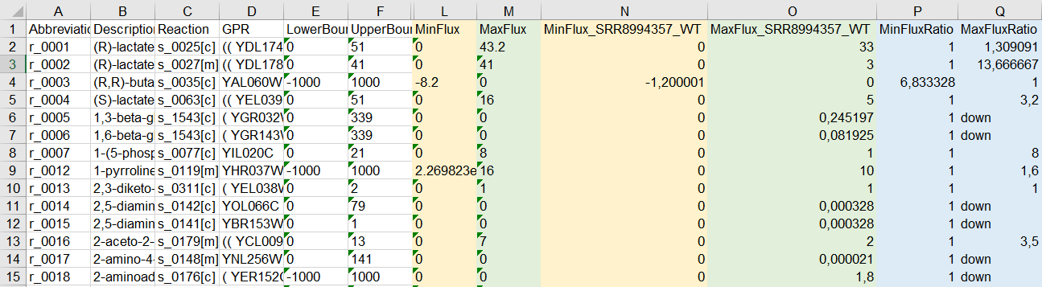

**Figure 17.** Reaction flux-shifts between two phenotypes

To perform this test case run the file *TestCase_calculateFluxShifts.m* in the *Scripts* folder of *IgemRNA* tool or run full tests from the root folder of *IgemRNA*:

*ShortTest.m*

*LongTest.m.*

Most genome scale metabolic models use biomass objective function to simulate biomass accumulation rates, but in many cases such, *S. cerevisiae* Yeast_8_4 version models have a specific wild type function. Optimizing different mutant strain models with deletions and/or specific omics data integration (like transcriptomics data), can yield infeasible optimization solutions although experimental conditions show the opposite. *IgemRNA* has functionality to remove biomass objective function from a model and apply flux distribution with transcriptome and/or medium data sets and analyze results.

1. Nomenclature of file names

*IgemRNA* also provides standardized output file naming for easier filtering of analysis datasets (Table 1).

**Table 1.** File name nomenclature.

|  |  |  |  |
| --- | --- | --- | --- |
|  | **Dataset and Phenotype Name** | **Thresholding Approach** | **Global Threshold Values** |
| Source | Sheet name in transcriptomics data file (Figure 1. B) | Based on the selected thresholding approach in the *IgemRNA* form section B (Figure 3.) | Based on the provided global threshold values in the *IgemRNA* form section C (Figure 3.) |
| Example/Possible values | SRR8994357_WT | * GT1 (Global T1) * LT1 (Local T1) * LT2 (Local T2) | * 30 (GT1, LT1) * 30_100 (LT2) |